
Dashboard Design

Date | 28 October 2026
Team ID | To be filled by team
Project Name | Healthcare Risk Analysis Dashboard using Tableau
Maximum Marks | 5 Marks

Activity 1: Interactive and visually appealing dashboards
Creating an effective Streamlit dashboard involves presenting business data stored in Snowflake through clear, interactive, and easy-to-understand visualizations. Students should design the dashboard so that users can quickly understand important KPIs, trends, comparisons, and business insights.
- Clear and Intuitive Layout
- Use Appropriate Visualizations
- Colour and Theming
- Interactive Filters and Slicers
- Drill-Down Capabilities
- Responsive Design
- Custom Visuals and Icons
- Use of Infographics

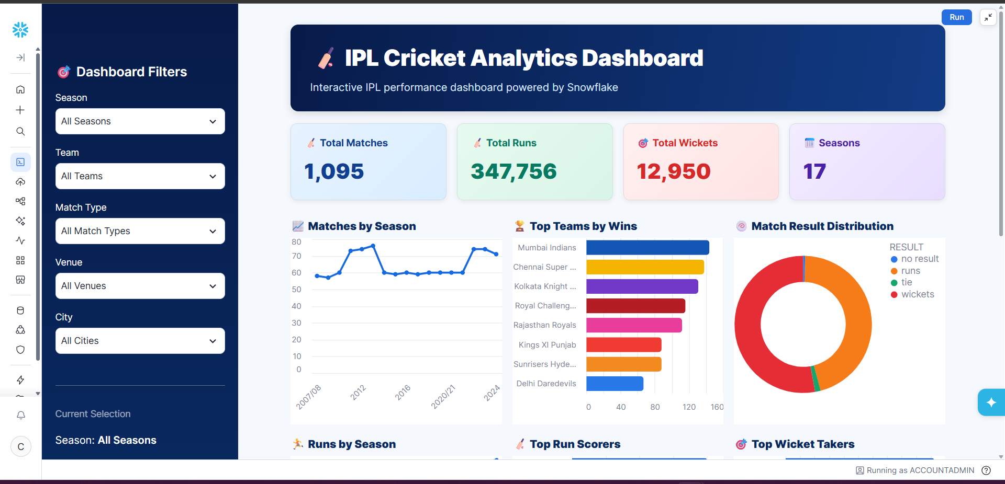
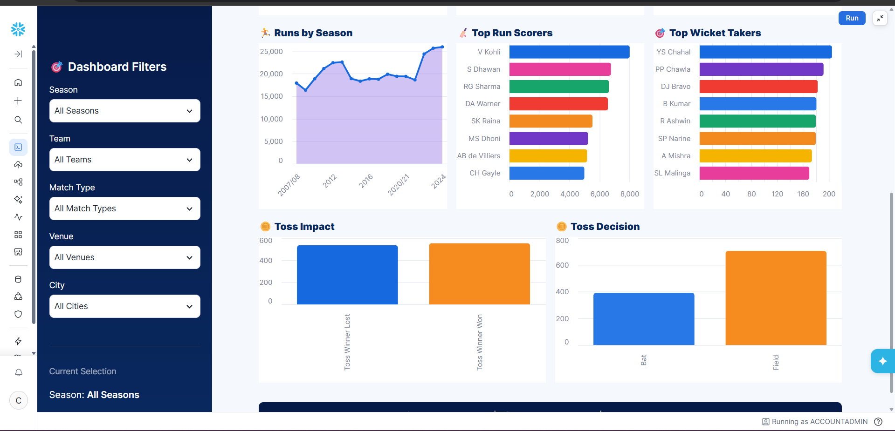
Note: Highlight the major outcomes in form of bullet points
Sample:
Here are five potential outcomes from the dashboard image provided:
- Mumbai Indians emerge as the strongest team by wins
Mumbai Indians are shown at the top of the Top Teams by Wins chart, indicating consistently strong performance across IPL seasons.
- Batting performance is dominated by a few key players
V. Kohli leads the Top Run Scorers chart, followed by players such as S. Dhawan, RG Sharma, and DA Warner. This highlights the importance of high-performing batsmen.
- Wicket-taking performance is concentrated among leading bowlers
YS Chahal ranks highest in the Top Wicket Takers chart, followed by PP Chawla and DJ Bravo, indicating that a relatively small group of bowlers has contributed significantly to wicket-taking.
- Fielding/toss decisions appear to have an impact on match outcomes
The Toss Impact and Toss Decision charts show differences between winning after winning the toss and choosing to bat vs. field. This can be used to investigate whether the toss provides a meaningful advantage.
- IPL match activity and scoring have grown over the seasons
The Matches by Season and Runs by Season charts show variation and an overall increase in IPL activity and run production across seasons, with particularly high run totals in later seasons.
Overall outcome: The dashboard suggests that IPL success is influenced by a combination of strong teams, elite batting and bowling performers, match/toss decisions, and changing scoring patterns across seasons.

Healthcare Dashboard Design Plan
Dataset: smart_healthcare_dataset (1).csv | 5,000 records | 16 fields. Purpose: descriptive exploration of demographic, clinical, lifestyle, symptom and disease-label patterns in Tableau.
Recommended dashboard layout
• Top row — KPI cards: Total Records (5,000), Heart Disease Cases, Diabetes Cases and Stroke Cases. Use counts and percentages of records; label these as dataset records, not population prevalence.
• Middle row — Age and Gender Patterns: disease-label counts by age band and gender; use grouped or stacked bars with readable legends.
• Lower row — Clinical Indicators: BMI, blood pressure, cholesterol and glucose distributions; use histograms or box plots and clearly label units.
• Lifestyle and Symptoms: compare smoking, alcohol and exercise level with disease labels; show counts or within-group percentages to avoid misleading raw-count comparisons.
• Filters: Gender, Age/Age Band, Smoking, Alcohol, Exercise Level and disease status where useful. Include a clear reset option.
• Design: use consistent Yes/No colors, descriptive chart titles, concise tooltips, a neutral background, and avoid overcrowding. Use dashboard-wide filters only where the fields apply.
Major outcomes to highlight (verify in Tableau)
• The dataset contains 5,000 records and 16 columns.
• Positive label counts: heart disease 1,499; diabetes 1,746; stroke 1,243.
• Dataset has no missing values and no exact duplicate rows according to a basic CSV check.
• health_risk_score is 100.0 for every record; it does not distinguish risk levels and should not be used as a ranking metric until its definition/source is verified.
• These are descriptive associations in the supplied dataset and do not establish causation or provide a medical diagnosis.
Activity 2 — Tableau Public publishing
Public dashboard link: To be added after you publish the completed workbook. Do not paste a sample link; use the URL generated by Tableau Public.

